**ASSIGNMENT 15.2**

PROBLEM STATEMENT:

1) Write a partial function to add three numbers in which one number is constant and two numbers can be passed as inputs and define another method which can take the partial function as input and squares the result.

Solutions:

**Partially applied function:**

“Partially applied functions” means functions where some of the arguments are applied.

Code and Output:



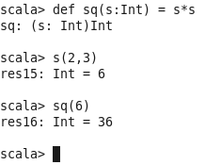

2) Write a program to print the prices of 4 courses of Acadgild: Android-12999, Big Data Development-17999, Big Data Development17999, Spark-19999 using match and add a default condition if the user enters any other course.

Solutions:

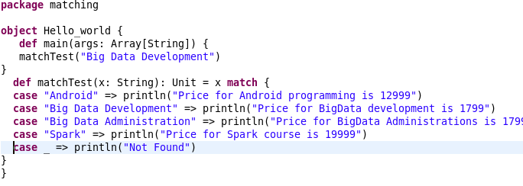

Output:

